Label Matrix Basics:

You can create new labels from scratch,, but it is probably easier to modify an existing one.
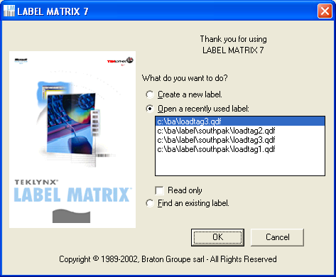

A “Sample” of the label that you selected is displayed when you say “OK” on the above screen.
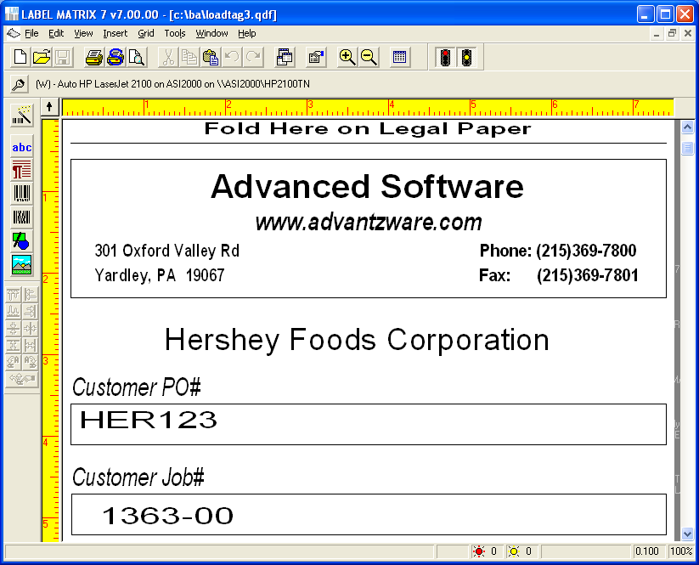

There are several types of data that Label matrix handles. The two most common are:
1. Constant data (such as your company name & address)
2. Database data (such as the PO #) that comes from our database.

You can single click a field to put it into “modifiable status” [ red brackets]. After a single click you can drag a field. With a double click you can change the information in a text field.

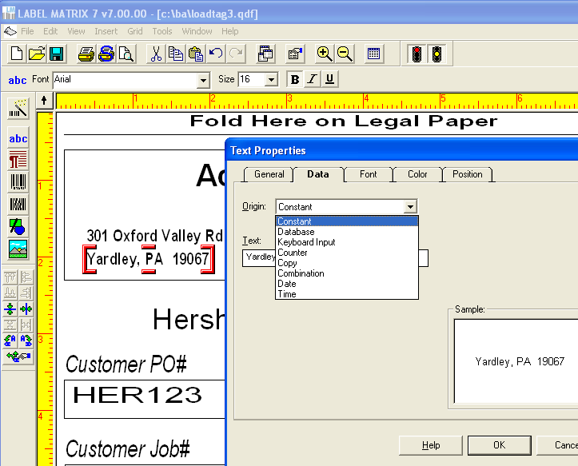

Database data allows yo to select which of the fields that are passed from Advantzware you want to display on the labels.

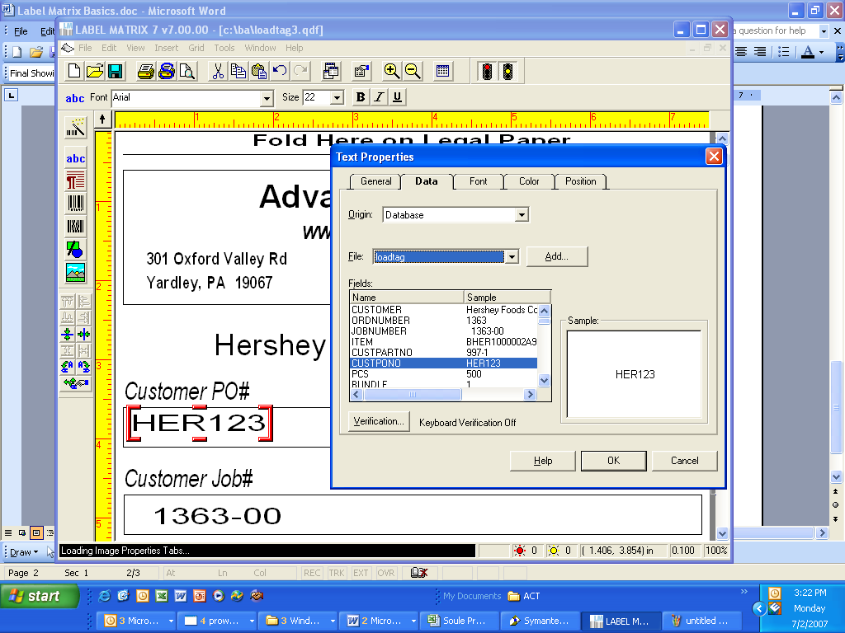

To add new data you place the cursor in the desired area (a large + sign shows the target area), then click ABC to add either constant or database data.

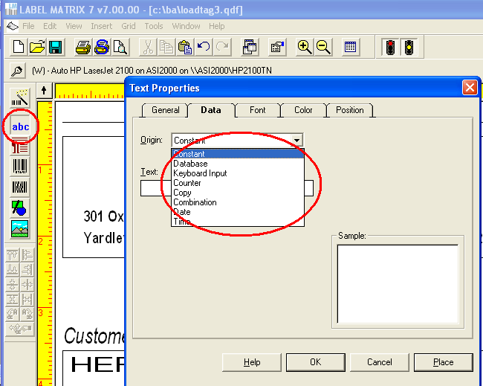

To add a bar code simply select the bar code icon and then select the database field that you want to add as a bar code.
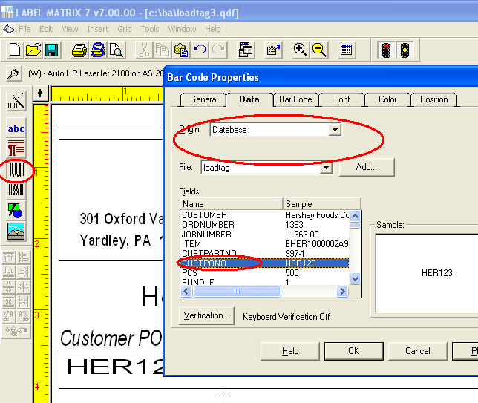

You can also change the font, size or color of any piece of data on the label.
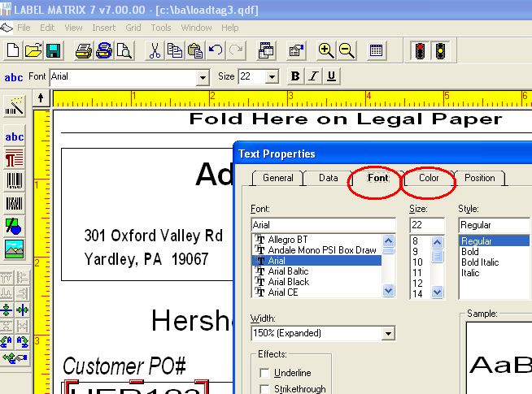

The newly modified label should now be saved as a new name (File, save as…)
